Micro-programmed Control Unit
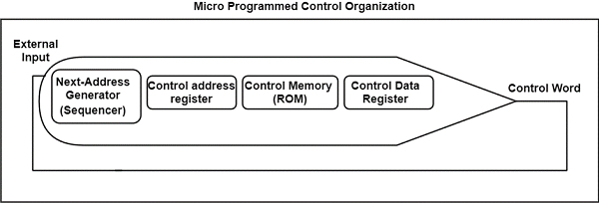
Fig: microprogram sequencer or nest address generator

Symbolic Microinstruction:
Label | Microoperations | CD | BR | AD
 |  | U | JMP
 |  | I | CALL
 |  | S | RET
 |  | Z | MAP

Fetch routine:
AR ← PC
DR ← M[AR] , PC ← PC + 1
AR ← DR(0-10) , CAR(2-5) ← DR(11-14) , CAR(0,1,6) ← 0
ORG64
Label | Microoperations | CD | BR | AD
FETCH | PCTAR | U | JMP | NEXT
 | READ,INCPC | U | JMP | NEXT
 | DRTAR | U | MAP
ABOVE IN BINARY
1000000 | 110 000 000 | 00 | 00 | 1000001
1000001 | 000 100 101 | 00 | 00 | 1000010
1000010 | 101 000 000 | 00 | 11 | 0000000
Label | Microoperations | CD | BR | AD
ADD | NOP | I | CALL | INDRCT
 | READ | U | JMP | NEXT
 | ADD | U | JMP | FETCH
 | ORG 4
BRANCH | NOP | S | JMP | OVER
 | NOP | U | JMP | FETCH
OVER | NOP | I | CALL | INDRCT
 | ARTPC | U | JMP | FETCH
 | ORG 8
STORE | NOP | I | CALL | INDRCT
 | ACTDR | U | JMP | NEXT
 | WRITE | U | JMP | FETCH

Decoding of microoperations:
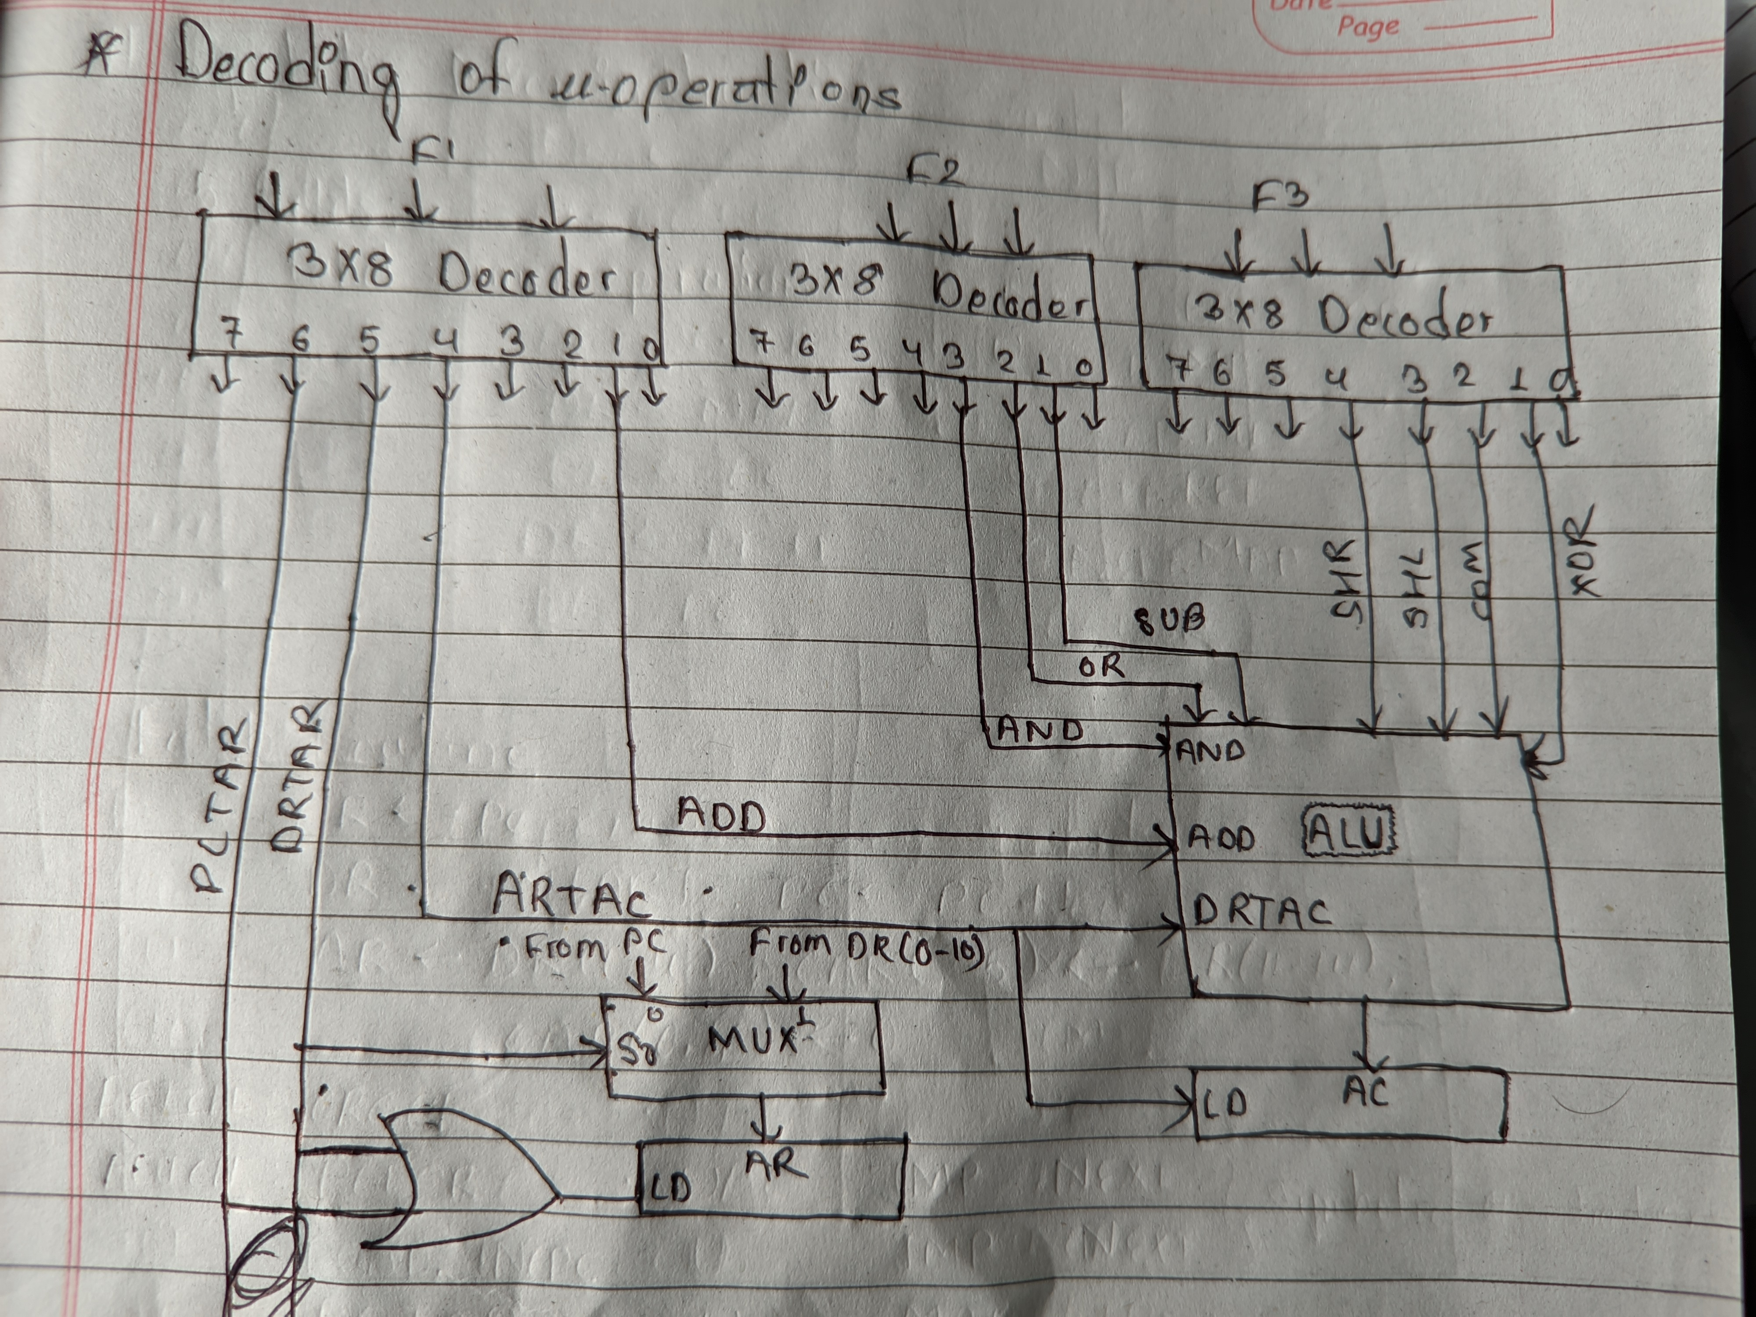

Design of control unit:
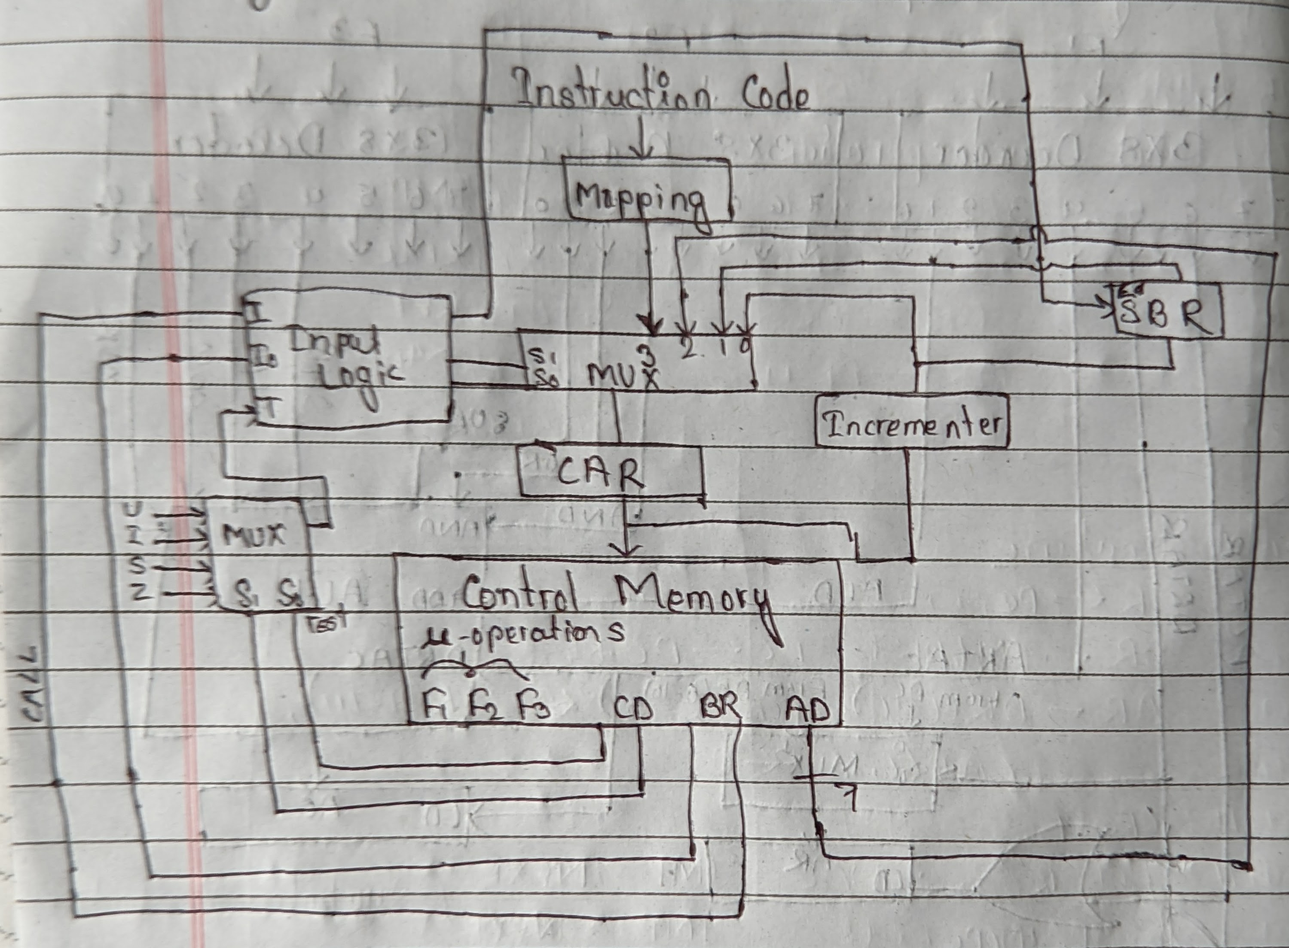

Circuit for Input logic:
I₁ | I₂ | T | S₁ | S₂ | LOAD SBR
0 | 0 | 0 | 0 | 0 | 0 NEXT
0 | 0 | 1 | 0 | 1 | 0 JMP
0 | 1 | 0 | 0 | 0 | 0 NEXT
0 | 1 | 1 | 0 | 1 | 1 CALL
1 | 0 | X | 1 | 0 | 0 RET
1 | 1 | X | 1 | 1 | 0 MAP

